Assignment 2

Use the ReducedMNIST which is a reduced version of the MNIST data set.

* **ReducedMNIST training**: 1000 examples for each digit.
* **ReducedMNIST test**: 200 examples for each digit.

1. Use multilayer perceptron (MLP) (it is also called Feedforward neural network (FFNN)) with 1, 2, or 3 hidden layers to solve this problem. You may use any of the features used in assignment 1. You are free to use any hyper-parameters of your own choice.
2. a. Use the ReducedMNIST data to train a CNN from the images without any use of a feature extraction step. Use the following structure to start with.

(Hint: you have to adjust your parameters to fit 28x28 images instead of 32x32, and use **ReLU** function as an activation function).

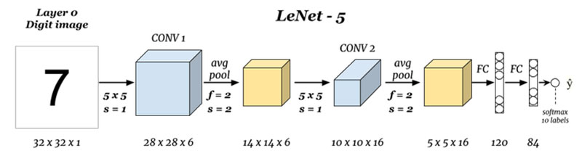



1. Make some at least two variations in the hyper-parameters of your choice and check the network performance, then give your comments. These changes may be in the number of filters in any convolutional layer, the activation function, adding or removing any layer…etc.
2. Compare among the results that you have obtained in this assignment with that you have obtained in Assignment 3 regarding (fill the following table).

|  |  |  |  |  |  |  |  |  |
| --- | --- | --- | --- | --- | --- | --- | --- | --- |
|  |  | **Features** | | | | | |  |
|  |  | **DCT** | | **PCA** | | **Your features** | |  |
|  |  | **Accuracy\*** | **Processing Time\*\*** | **Accuracy** | **Processing Time** | **Accuracy** | **Processing Time** | **from assignment 1** |
| **Classifier** | |  |  |  |  |  |  |
| **K-means Clustering** | **1** |  |  |  |  |  |  |
| **4** |  |  |  |  |  |  |
| **16** |  |  |  |  |  |  |
| **32** |  |  |  |  |  |  |
| **SVM\*\*\*** | **Linear** |  |  |  |  |  |  |
| **Nonlinear:** |  |  |  |  |  |  |
| **Multi-layer Perceptron (MLP)** | | | | | | | | **Assignment 2** |
|  |  | **DCT** | | **PCA** | | **Your features** | |
|  | **Variations** | **Accuracy\*** | **Processing Time\*\*** | **Accuracy** | **Processing Time** | **Accuracy** | **Processing Time** |
| **MLP** | **1-Hidden** |  |  |  |  |  |  |
| **2-Hidden** |  |  |  |  |  |  |
| **3-Hidden** |  |  |  |  |  |  |
| **In the CNN no Features are needed** | | | | | | | |
|  | **Variations** | **Accuracy** | **Training time** | | **Testing time** | |  |
| **CNN\*\*\*\*** | **Variation1:** |  |  |  |  |  |  |
| **Variation2:** |  |  |  |  |  |  |
| **Variation3:** |  |  |  |  |  |  |
| **Variation4:** |  |  |  |  |  |  |
| * Accuracy to be as % with one friction digit like 89.5% | | | | | | | |  |
| ** Processing time in milli-seconds like 10.3 msec. | | | | | | | | |
| *** mention the kernel name and its specs | | | | | | | | |
| **** describe each variation in short in the corresponding cells | | | | | | | | |

1. Given the speech data (train and test) for the 10 digits uttered by many speakers, develop and train a network to recognize any given new digit using the spectrogram of each digit as the training and testing data. You may convert the speech data to images and deal with the speech problem as if it is an object recognition problem in images. (Hint: you may start from the network in problem 1 and enhance by make some alternations in the hyper-parameters or start from any of the networks that have been used in the ImageNet problem).

Examples of spectrum images for some digits